**Case Studies & Guesstimates for FinTech Industries**

The FinTech industry has emerged as a dynamic and transformative force in the financial sector, integrating technology with financial services to enhance efficiency, accessibility, and customer experience. In today's era, FinTech is crucial for democratizing financial services, providing underserved populations with access to banking, credit, and investment opportunities. It fosters innovation through digital payment systems, peer-to-peer lending platforms, and blockchain technology, revolutionizing traditional banking practices.

Data scientists play a pivotal role in the growth of FinTech by leveraging advanced analytics and machine learning to improve risk assessment, fraud detection, and personalized financial services. Their expertise enables FinTech companies to analyze vast amounts of financial data, uncovering insights that drive strategic decision-making, optimize operations, and enhance customer satisfaction. By harnessing the power of data, data scientists help FinTech firms stay competitive, innovate continuously, and contribute to a more inclusive and efficient financial ecosystem.

# **PART - I**

# **Product Dissection**

## **1. Platform Selection**

**Question:** Choose a leading platform from a domain related to the **FinTech** industry. Justify your selection by discussing the platform's popularity, impact, and relevance in its industry.

**Answer:** PhonePe

### **Popularity :** PhonePe is one of India’s leading fintech companies, revolutionizing digital payments through UPI, mobile wallets, and banking services. Launched in 2015 and acquired by Flipkart in 2016, PhonePe has grown to become a dominant player in India’s fintech ecosystem, enabling secure and fast transactions for millions of users.PhonePe’s USP lies in its ability to combine speed, security, and a wide range of services under one platform. It’s not just a payment app—it’s a comprehensive financial ecosystem that caters to diverse needs, from simple money transfers to investments and insurance, all while offering a secure, user-friendly experience.Backed by Flipkart, one of India’s largest e-commerce giants, PhonePe has built strong brand credibility, ensuring users feel confident about transaction security.

### **Impact :** PhonePe has revolutionized money management in India, driving the success of UPI with seamless money transfers, bill payments, and everyday transactions. But it’s more than just a payment app—users can recharge phones, buy gold, get insurance, and invest in mutual funds, all in one place.It empowers small businesses, reduces cash dependency, and enhances financial inclusion. With top-notch security, AI-driven fraud detection, and an intuitive design, PhonePe makes digital payments safe, simple, and accessible for everyone.



### **Relevance:** In today’s fast-paced economy, instant access to financial services is essential. PhonePe meets this demand with a comprehensive digital payments and financial services platform. Beyond simple transactions, it offers bill payments, investments, insurance, and merchant payments, creating a seamless financial ecosystem.Leveraging data science, PhonePe analyzes consumer behavior, predicts transaction patterns, and personalised services for enhanced convenience. Its user-friendly interface, robust security, and diverse offerings make it a key player in India’s digital financial landscape, empowering users to manage their finances effortlessly from their smartphones.

## **2. Core Features and Functionalities**

**Question:** Research and list the core features and functionalities of the selected platform. Describe how these features contribute to the platform’s success and user engagement.

**Answers:** Core Features and Functionalities of PhonePay

### **1. Convenience:**

* **AutoPay:** Automates recurring payments for bills and subscriptions, saving time and effort.
* **PhonePe Wallet:** Allows users to store funds for quick transactions without the need to link a bank account for every payment.
* **Money Transfer to Bank:** Enables hassle-free withdrawal of funds from the wallet to bank accounts.
* **Merchant Payments Solution:** Simplifies payments for businesses with tools like QR codes, payment links, and POS devices.

#### 

### **2. UI/UX (User Interface & User Experience):**

* **User-Friendly Interface:** Clean, intuitive design makes it easy for users to navigate and complete transactions.
* **Multi-language Support:** Available in several Indian languages, enhancing usability across diverse regions.
* **PhonePe Switch:** Provides a super-app experience by integrating third-party apps within PhonePe, offering a seamless transition between services.
* **Transaction History & Analytics:** Offers detailed insights into spending patterns, enhancing financial management.

#### 

### 

### **3. Range of Choice:**

* **UPI Payments:** Facilitates instant peer-to-peer and merchant transactions via UPI.
* **Bill Payments & Recharges:** Covers a wide range of services, including utility bills, mobile recharges, DTH, and broadband payments.
* **QR Code Payments:** Enables quick offline payments with QR code scanning, supporting a variety of merchants.
* **Investment Platform:** Offers options to invest in mutual funds, gold, and other financial products.
* **Insurance Services:** Provides diverse insurance products like health, car, bike, and travel insurance.
* **Credit Services:** Includes personal loans and buy-now-pay-later options through partner financial institutions.

### **4.Price or Miscellaneous:**

* **Rewards & Cashbacks:** Incentives like cashback, discounts, and loyalty programs.
* **Fees:** Most services are free; some transactions may have nominal charges for card payments, wallet loading, and merchant transactions.
* **Cost-Effective:** Minimal fees keep it budget-friendly.

### 

### **Contribution to Success and User Engagement:**

* **Seamless Convenience:** With a wide range of payment options and wallet features, PhonePe makes transactions effortless anytime, anywhere.
* **Simple, Smart Design:** Its intuitive interface ensures even first-time users can navigate with ease, creating a hassle-free digital payment experience.
* **Rewards That Keep You Coming Back:** Generous cashback, exciting rewards, and exclusive deals turn everyday transactions into rewarding experiences.
* **Secure & Trustworthy:** Advanced security features like PIN and biometric authentication give users peace of mind, building trust with every transaction.
* **Beyond Payments:** With investment options and financial services, PhonePe isn’t just an app—it’s your all-in-one financial companion.

## **3. Real World Problems**

**Question:** Identify the real-world problems that the platform aims to solve. Discuss how the platform addresses these problems through its features and functionalities.

### **Answer: Real-World Problems Addressed by PhonePe**

#### **1. Access to Convenient Digital Payments:**

* + **Problem:** Many individuals face difficulties in accessing convenient, secure digital payment methods, especially in rural areas where bank branches and ATMs may be scarce.
  + **Solution:** PhonePe has made digital payments accessible to everyone through its UPI-based payment system, mobile wallet, and easy-to-use interface, ensuring that users can make payments quickly and safely without the need for physical visits to banks or payment centers.

#### **2. Cash Dependency:**

* + **Problem:** Many people, particularly in rural areas, are still reliant on cash for day-to-day transactions, which can be inconvenient and unsafe.
  + **Solution:** PhonePe encourages cashless transactions by providing simple, secure, and instant alternatives for paying bills, recharging phones, transferring money, and more. This helps reduce the reliance on cash and the risks associated with carrying it.

#### **3. Bill Payments and Recurring Expenses:**

* + **Problem:** Managing multiple bills for electricity, water, phone, and DTH services can be time-consuming and tedious, often requiring visits to different service providers.
  + **Solution:** PhonePe consolidates bill payments and recharge services into one platform, allowing users to manage all their recurring expenses efficiently and on time, saving both time and effort.

#### **4. Transaction Security:**

* + **Problem:** Users are often concerned about the security of digital transactions, especially with the rise of online fraud and scams.
  + **Solution:** PhonePe incorporates robust security features like PIN, biometric authentication, and two-factor authentication to ensure that all transactions are secure, and users’ data is protected.

#### **5. Financial Inclusion:**

* + **Problem:** A significant portion of the Indian population lacks access to financial services such as savings accounts, insurance, and investment opportunities.
  + **Solution:** By offering investment options like gold, mutual funds, and insurance on the same platform, PhonePe promotes financial inclusion, enabling users to manage their finances better and access services that were previously out of reach.

#### **6. Peer-to-Peer Transactions:**

* + **Problem:** Transferring money to friends and family can be cumbersome, especially when one person needs to pay for a group expense or a shared service, often requiring bank details or physical meetings.
  + **Solution:** The Peer-to-Peer Money Transfer feature allows users to send money instantly and securely to anyone with a PhonePe account, even without needing to know their bank details, making it fast and hassle-free.

#### **7. Merchant Payment Systems:**

* + **Problem:** Small and medium-sized businesses often face challenges in adopting modern digital payment methods due to high fees, complex integrations, or technical barriers.
  + **Solution:** PhonePe enables merchants, including small vendors, to accept payments through QR codes, providing a cost-effective and user-friendly method for businesses to adopt digital payments without complicated setups.

### **How PhonePe Addresses These Problems:**

* **Access and Convenience:** PhonePe's UPI-based payment system and wallet integration make it easy to perform digital transactions, reducing dependency on cash and physical visits.
* **Financial Inclusion:** By offering services like gold and mutual fund investments, PhonePe addresses the financial needs of underserved populations, promoting economic growth.
* **Security:** The platform's strong security measures ensure that users can make transactions with confidence, mitigating concerns about fraud and cyber threats.
* **Ease of Transactions:** With features like peer-to-peer transfers, bill payments, and merchant payments, PhonePe makes everyday transactions faster, simpler, and more efficient, saving time and effort.

# **Database Management & Schema Design**

## 

## **4. Schema Design**

**Question:** Based on the features and functionalities you have identified, design a schema that reflects the platform’s data structure. Define the key entities, attributes, and relationships that underpin these features.

**Answers: Schema Design for PhonePay**

The schema design for PhonePe should reflect its core features and functionalities, ensuring efficient data management and enabling the platform to deliver a seamless user experience. Below is an overview of the key entities, attributes, and relationships:

### 

### **Key Entities and Attributes:**

I'll create a comprehensive entity-relationship breakdown for PhonePe, a digital payment platform. Here are the key entities and their relationships:

## 

### **Core Entities**

#### **UsersTable**

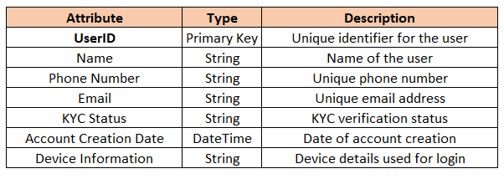

#### **Wallet Table**

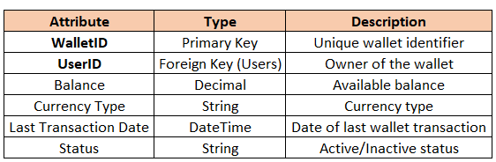

#### **Bank Accounts Table**

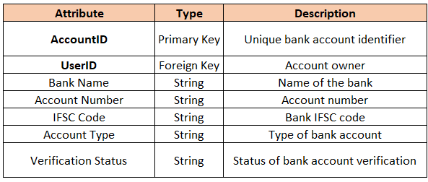

#### **Transactions Table**

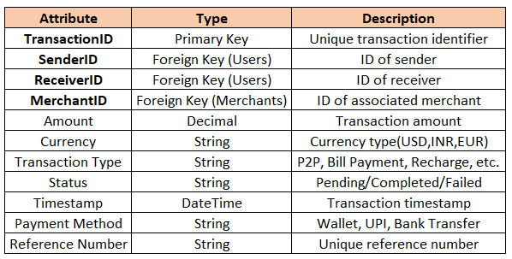

#### **Merchants Table**

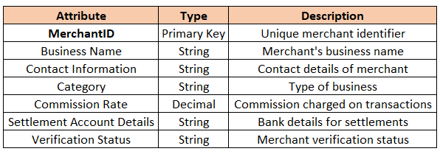

#### **Payment Instrument Table**

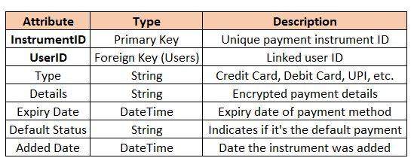

### **Relationship Mapping**

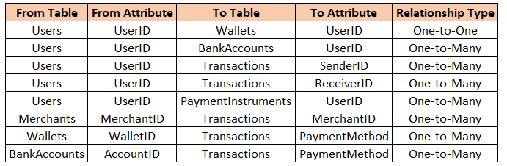

### 

### 

### 

## **5. ER Diagram Creation**

**Question:** Utilise tools like the Miro platform or similar applications to create an illustrative Entity-Relationship (ER) diagram. This diagram should vividly depict the entities, attributes, and relationships present within your schema design.



# **Revenue and Profit Growth Strategies**

**Question:** After completing the product dissection and schema design steps for the chosen platform, conduct a comprehensive case study on the above chosen industry. Your goal is to identify and propose strategies to increase the **profit of the industry by at least 25%**.

Create a detailed report summarising your findings and proposals. Include data-driven justifications for each proposed strategy and present your case study using visual aids such as charts, graphs, and diagrams to illustrate your points. Outline the steps, resources, and timeline required to achieve the desired revenue and profit growth.

To boost the phonepay profit by 25% , analyzing financial data like revenue streams , expenses and customer behaviour is required to develop an efficiency strategy.

PhonePay’s Net Profit of 2024 is **₹197 crore**.

We need to boost this profit by 25% to ₹ **246.25 crore**.

### **1. Analysing PhonePay’s current status**

#### **Current Financial Data**

|  |  |
| --- | --- |
| **Category** | **Details** |
| **Revenue Sources** | **Revenue from payment processing, subscriptions,merchant services, and advertising.** |
| **Expenses** | **Operational costs including transaction fees, marketing, technology, and employee salaries.** |

#### **Sources of Revenue**

|  |  |
| --- | --- |
| **Revenue Stream** | **Details** |
| **Payment Processing** | **Revenue from processing payments for businesses (transaction fees) not individuals.** |
| **Subscriptions** | **Revenue from value-added services like PhonePe Insurance or Loans and credit.** |
| **Merchant Services** | **Revenue from businesses using PhonePe for payment acceptance.(PlatformFee,POS ,Merchant Dashboards, Integration tools)** |
| **Advertising** | **Revenue from ads placed on the platform (either in-app or targeted advertising).** |
| **Partnerships & Cross-Selling** | **Income from partnerships with financial institutions or upselling products like digital gold.** |

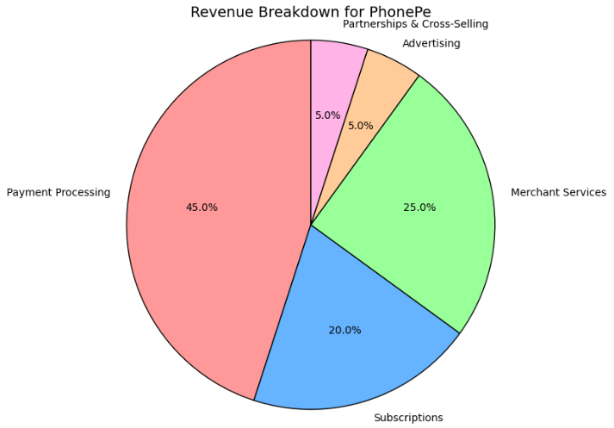

#### **Sources of Expenses**

|  |  |
| --- | --- |
| **Expense Category** | **Details** |
| **Payment Gateway Fees** | **Transaction fees paid to banks or other financial institutions.** |
| **Technology Infrastructure** | **Costs associated with maintaining the platform, cloud services, and security.** |
| **Marketing & Advertising** | **Costs incurred for customer acquisition through social media, digital ads, etc.** |
| **Employee Salaries** | **Costs of workforce including developers, support staff, and marketing professionals.** |
| **Partner Fees** | **Fees paid to third-party providers for financial services (e.g., insurance, loan providers).** |

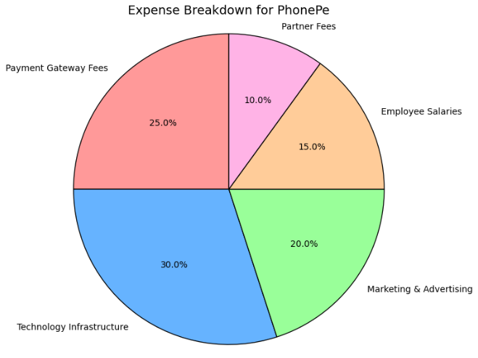

### 

### **Customer Acquisition & Retention**

|  |  |
| --- | --- |
| **Category** | **Details** |
| **Acquisition Channels** | **Social media ads, referral programs, influencer marketing, app store promotions.** |
| **Retention Strategies** | **Loyalty programs, personalized offers, and payment reminders.** |
| **Churn Analysis** | **Understand reasons why users stop using the app and how to address pain points (e.g., high transaction fees, app glitches).** |

### 

### **2.Focus Areas for Increasing PhonePe's Profit by 25%**

|  |  |  |  |
| --- | --- | --- | --- |
| **Category** | **Focus Area** | **Measures** | **Estimated Impact** |
| **Internal Management** | **Operational Efficiency** | **Implement AI-powered transaction processing, optimize payment gateways.** | **6%** |
|  | **Employee Productivity** | **Training staff, enhancing customer support response times.** | **1%** |
|  | **Payment Gateway Optimization** | **Negotiate lower transaction fees with financial partners.** | **2%** |
| **Product Strategy** | **New Value-Added Services** | **Introduce new services like micro-loans, insurance products.** | **3%** |
|  | **Cross-Selling/Up-Selling** | **Offer insurance, digital gold, or loan services as additional products in transaction flow.** | **3%** |
| **Market Expansion** | **Geographic Expansion** | **Expand PhonePe services to tier-2 and tier-3 cities.** | **2%** |
|  | **Market Penetration** | **Increase market share in metro cities by enhancing brand presence.** | **2%** |
| **Post-Sales Management** | **Customer Retention** | **Personalized offers, subscription models for users.** | **1%** |
|  | **Customer Support** | **Implement AI chatbots for faster response, improve issue resolution.** | **1%** |
| **Branding & Marketing** | **Digital Marketing** | **Enhance social media presence, invest in SEO and app store optimization.** | **1%** |
|  | **Referral Programs** | **Reward existing users for referring new users to PhonePe.** | **2%** |
|  | **Community Engagement** | **Promote financial literacy, partnerships with financial institutions.** | **1%** |

### **3.Defining Strategies**

1. **Optimizing Expenses**
   * **Automate Payment Processing**: Leverage AI to streamline and automate payment verification, transaction processing, and fraud detection.
   * **Negotiate Payment Gateway Fees**: Work with financial institutions to negotiate lower transaction fees for users and merchants.
   * **Optimize Marketing Spend**: Reduce customer acquisition costs by focusing on the most effective channels like referral programs and targeted advertising.
2. **Enhancing Revenue Streams**
   * **Expand Value-Added Services**: Introduce new financial products like micro-loans, insurance, and savings plans to increase revenue.
   * **Cross-Sell Financial Products**: During transaction flows, promote services like digital gold, insurance, or loans to increase average revenue per user.
   * **Merchants & Partnerships**: Partner with more businesses and service providers to expand the merchant network using PhonePe.
3. **Improving Customer Satisfaction & Retention**
   * **Loyalty Programs**: Implement a points-based loyalty program that rewards frequent users with discounts on services or higher transaction limits.
   * **Improve Customer Support**: Integrate AI-powered chatbots for 24/7 customer support, resolve issues faster, and reduce churn rates.
   * **Personalized Offers**: Use customer data to provide personalized offers and cashback based on transaction history, increasing repeat usage.
4. **Expanding Market Reach**
   * **Geographic Expansion**: Focus on expanding to tier-2 and tier-3 cities where digital payment adoption is growing but remains underserved.
   * **Metro Market Penetration**: In metro cities, increase market penetration by offering faster and more convenient payment options for both users and merchants.

### **4. Impact Breakdown**

With the current profit of **₹197 crore**, the focus is to increase that profit by ₹49.25 crore to reach a target profit of **₹246.25 crore**. Here's how each strategy can contribute to this

|  |  |  |  |  |
| --- | --- | --- | --- | --- |
| **Category** | **Focus Area** | **Measures** | **Estimated Impact** | **Contribution To Profit In Crores** |
| **Internal Management** | **Operational Efficiency** | **Implement AI-powered transaction processing, optimize payment gateways.** | **6%** | **11.82** |
|  | **Employee Productivity** | **Training staff, enhancing customer support response times.** | **1%** | **1.97** |
|  | **Payment Gateway Optimization** | **Negotiate lower transaction fees with financial partners.** | **2%** | **3.94** |
| **Product Strategy** | **New Value-Added Services** | **Introduce new services like micro-loans, insurance products.** | **3%** | **5.91** |
|  | **Cross-Selling/Up-Selling** | **Offer insurance, digital gold, or loan services as additional products in transaction flow.** | **3%** | **5.91** |
| **Market Expansion** | **Geographic Expansion** | **Expand PhonePe services to tier-2 and tier-3 cities.** | **2%** | **3.94** |
|  | **Market Penetration** | **Increase market share in metro cities by enhancing brand presence.** | **2%** | **3.94** |
| **Post-Sales Management** | **Customer Retention** | **Personalized offers, subscription models for users.** | **1%** | **1.97** |
|  | **Customer Support** | **Implement AI chatbots for faster response, improve issue resolution.** | **1%** | **1.97** |
| **Branding & Marketing** | **Digital Marketing** | **Enhance social media presence, invest in SEO and app store optimization.** | **1%** | **1.97** |
|  | **Referral Programs** | **Reward existing users for referring new users to PhonePe.** | **2%** | **3.94** |
|  | **Community Engagement** | **Promote financial literacy, partnerships with financial institutions.** | **1%** | **1.97** |
|  |  | **Total** | **25%** | **49.25** |

By adopting an **inside-out methodology,** one can systematically address key areas to drive profitability. Focusing first on optimizing expenses, then enhancing customer satisfaction and retention, and finally boosting revenue streams provides a structured approach to achieving a significant profit increase. Using data-driven insights at each step ensures that decisions are based on solid evidence, leading to more effective and sustainable improvements. This comprehensive approach will help PhonePay to achieve the desired 25% profit increase.

# **PART - II**

## **Guesstimates**

### **1. What will be the percentage increase in global FinTech investments over the next five years?**

Current Status (2025)

Market Share: 49% of UPI transactions

Valuation (2025): ₹1 Lakh Crore $12B

Investment Received So Far: ₹16,600 Crore ($2B )

FinTech Industry Growth Rate: 20-25% CAGR

PhonePe's Expected Growth Rate: 28-30% CAGR

**Projected Valuation in 2030**

Using the CAGR formula:

Future value = Present Value * ( 1+ Growth Rate)^Year

Assuming 28% CAGR for phonepe

12B * (1.28)^5≈ 41B

PhonePe’s projected valuation in 2030: **$41 Billion** (₹3,41,000 Crore)

**Projected Investment Growth by 2030**

Investment in 2025: $2B

If investments grow 28% CAGR:

2B×(1.28) ^5 ≈ 6.9B

**PhonePe’s projected investment in 2030: $6.9 Billion**

**Percentage Increase in Investment (2025-2030)**

Percentage Increase = ((Future Value - Present Value) / Present Value) × 100

= (6.9B - 2B / 2B ) * 100 = 245%

Investment is expected to grow by approximately **245% over 5 years.**

**Key Takeaways for PhonePe (2025-2035)**

**Valuation Growth: From $12B (2025) → $41B (2030)**

**Investment Growth: From $2B (2025) → $6.9B (2030)**

**Main Growth Drivers:**

* UPI dominance & digital payment expansion
* Growth in loans, insurance, and wealth management
* Higher user retention & increased transaction volume
* International expansion possibilities

### **2. How many people will adopt digital banking services in developing countries over the next decade?**

Total Population: 1.43 billion

Internet Users: 1.1 billion

UPI Users: 500 million

PhonePe’s UPI Market Share: 49%

Financial Inclusion Gap: A large number of rural and semi-urban users still rely on cash

Smartphone Penetration: Expected to reach 80% by 2030

#### **Growth Rate Assumption:**

UPI adoption saw **50% YoY growth** in past years

Future growth will **stabilize at ~12–15% CAGR** over the next decade

Using CAGR formula:

Assuming 14% CAGR over the next decade  
 **Future Users = 500M × (1.14)^10 ≈ 850M**

So, by **2035**, ~**850 million Indians** could be using UPI and digital banking services

**PhonePe’s User Growth**

2025: PhonePe holds **49%** of UPI market  
 Even with competition, assuming **~42% market share** in 2035:  
 850M × 0.42 = **357M users**

So, PhonePe could serve **~357–360 million users** by 2035

**Key Takeaways for PhonePe (2025-2035)**

UPI/Digital Banking Users: From 500M (2025) → 850M+ (2035)

PhonePe Users: From 245M (2025) → ~360M+ (2035)

**Main Growth Drivers:**

* **Smartphone & Internet Boom**: Deeper penetration in Tier 2, Tier 3 cities & rural India
* **UPI Expanding into Financial Services**: Lending, Credit, Insurance, Investments
* **Simplified User Experience**: Voice-enabled UPI, vernacular support, QR expansion

### **3. What percentage of small and medium-sized enterprises (SMEs) will use FinTech solutions for their financial needs by 2025?**

**Total SMEs in India** = 42.2 million  
 **SMEs using UPI/Digital Payments in 2024** = 27%  
 → 27% of 42.2M = 11.39M SMEs

**PhonePe’s Market Share (2025)** = 49%  
**Projected Growth Rate for SME FinTech Adoption** = 23% CAGR

Future Value = Present Value × (1 + Growth Rate)^Years

**FinTech-Using SMEs in 2025** 11.39M × (1.23)^1 = 11.39M × 1.23 = **14.01M SMEs**

So, ~14 million SMEs expected to use FinTech in 2025  
 (14.01M / 42.2M) × 100 = **33.2% SMEs**

**PhonePe’s Expected SME Users (2025)** 14.01M × 0.49 = **6.86M SMEs** So, PhonePe could have ~6.9 million SME users in 2025

**Key Takeaways for PhonePe**

SMEs using FinTech (2024): 11.39M (27% of 42.2M)

Projected in 2025: 14M (33.2%)

PhonePe’s SME Users (2025): ~6.9M

**Main Growth Drivers**

* More digital lending + UPI tools added for SMEs
* Strong government push for SME digitization
* Rising smartphone + internet access in small businesses

### **4. What will be the average transaction value of mobile payments in the next three years?**

Current UPI Transaction Trends (2025)

Total UPI Transaction Value (2025): ₹180 Lakh Crore ($2.2 Trillion)

Total UPI Transactions (2025): 150 Billion

Average Transaction Value (ATV) in 2025: Total UPI Transaction Value /

Total UPI Transaction

= 180 L / 150 B

= ₹1,200 per transaction

PhonePe’s Market Share (2025): 49% of UPI transactions

PhonePe’s Total Transactions (2025): 73.5 Billion

PhonePe’s Transaction Value (2025): ₹88.2 Lakh Crore

Projected Growth Rate for ATV (2025-2028)

**Assumed Growth Rate**

ATV Growth Rate Projection: 15-18% CAGR

Future Value=Present Value×(1+Growth Rate)^Years

**Predicted ATV Growth (2025-2028)**

Assuming 16% CAGR

Projected ATV for PhonePe UPI Payments **2026 = 1,200×(1.16)^1 ≈ ₹1,392 per transaction**

Projected ATV for PhonePe UPI Payments **2027 = 1,200×(1.16)^2 ≈ ₹1,615 per transaction**

Projected ATV for PhonePe UPI Payments **2028 = 1,200×(1.16)^3 ≈ ₹1,874 per transaction**

**Expected PhonePe Impact (2028)**

**Total PhonePe UPI Transactions (2028 Estimate): 100 Billion**

Projected PhonePe Transaction Value (2028): 100 B × 1,874 ≈ ₹187.4LakhCrore

**Key Takeaways for PhonePe**

ATV Growth: From ₹1,200 (2025) → ₹1,874 (2028) (16% CAGR)

Total Transaction Value: ~₹187.4 Lakh Crore (by 2028)

**Main Growth Drivers:**

* Rise in **high-value UPI payments**
* Use of **credit via UPI** (like Credit Line on UPI)
* More digital spending across India

### 

### **5.How much will blockchain technology reduce the costs of cross-border transactions in the next five years?**

**UPI Global** is expanding to UAE, Singapore, Nepal, Sri Lanka, France, UK

**PhonePe’s Goal**: Enable **low-cost**, real-time cross-border payments

**Blockchain** can help cut costs by removing middlemen like **correspondent banks**

**Projected Cost Reduction Using Blockchain (2025-2030)**

|  |  |  |  |
| --- | --- | --- | --- |
| **Year** | **Traditional Cost (%)** | **PhonePe UPI Cost (%)** | **Blockchain-Enabled Cost(%)** |
| 2025 | 5-7% | 1-2% | 1.0% |
| 2026 | 4.5% | 1.5% | 0.9% |
| 2027 | 4.2% | 1.3% | 0.8% |
| 2028 | 3.8% | 1.1% | 0.7% |
| 2029 | 3.5% | 1.0% | 0.6% |
| 2030 | 3.0% | 0.8% | 0.5% |

**Estimated Cost Savings Over 5 Years**

**Assumption:**

Cross-border UPI transactions via PhonePe in 2025 = ₹50,000 Crore (~$6B)

Assume Growth rate = **20% CAGR** per year

Blockchain reduces transaction cost from **1.5% (2025) → 0.5% (2030)**

**Savings Calculation**

**Cost Savings = Transaction Volume × (Old Cost % − New Cost %)**

2025 Cost Savings: ₹50,000 Cr × (1.5% - 1.0%) = ₹250 Cr saved

2026 Cost Savings: ₹60,000 Cr × (1.3% - 0.9%) = ₹240 Cr saved

2027 Cost Savings: ₹72,000 Cr × (1.1% - 0.8%) = ₹216 Cr saved

2028 Cost Savings: ₹86,400 Cr × (1.0% - 0.7%) = ₹259 Cr saved

2029 Cost Savings: ₹1,03,680 Cr × (0.8% - 0.6%) = ₹207 Cr saved

2030 Cost Savings: ₹1,24,416 Cr × (0.5%) = ₹622 Cr saved

**Total Estimated Savings via Blockchain (2025-2030): ₹1,794 Crore ($220M)**

**Key Takeaways for PhonePe**

* **Massive Cost Savings** → ₹1,794 Cr saved in 5 years
* **Cheaper than** SWIFT, Western Union, PayPal

# **PART - III**

## **Scenario Based Questions**

#### 

### **Scenario 1:**

A fintech company offers a mobile payment app where users can link their bank accounts and make payments. The company wants to analyse the retention of users who signed up for the app in the past six months to understand how often they continue using it after the initial download.

### **Question 1:How would you perform a cohort analysis to calculate the monthly retention rate for users who signed up in different months?**

To calculate the monthly retention rate for users who signed up in different months, I would conduct a cohort analysis by:

#### **1.Define Cohort**

* Define an "active user" as someone who **made at least one transaction** in a given month.
* Track whether users from each cohort are still making transactions in subsequent months.

#### **2.Key Metrics to Track**

##### **1. Retention & Churn Metrics**

### **Monthly Retention Rate**

Percentage of users from a cohort who remain active in subsequent months.

**Retention rate** = (Users active in month n / Users in cohort)*100

### 

### 

### 

### **Churn Rate**

Percentage of users who stop transacting within a given period.

**Churn Rate** = 1- Retention Rate

##### **2. User Engagement Metrics**

**Monthly Active Users (MAU) & Daily Active Users (DAU)**

Number of unique users who make a transaction in a month/day.

##### **3.Average Revenue Per User (ARPU)**

Revenue generated per active user. **ARPU**=Total Revenue/Total active users

##### **4. User Growth Rate**

Percentage increase in new users over time. **Growth Rate**=(New Users in Period/Total Users in Previous Period)×100

#### **3. Customer Satisfaction & Loyalty Metrics**

##### **User Complaints**

Number of complaints per 1,000 transactions

##### Refund Rate

Percentage of transactions that get disputed or refunded.

Refund Rate =(Number of Refunded Transactions/ Total Transactions)x 100

### **Cohort Analysis Structure:**

* If retention drops sharply after **Month 1**, focus on **improving the onboarding experience**.
* If retention declines steadily over time, introduce **loyalty programs, cashback offers, or personalized recommendations** to encourage repeat transactions.
* Compare cohorts over time to see if recent product changes improved retention.

### **Question 2: If you find that retention drops significantly after the first month, what are some possible reasons for this behaviour, and how can the company address this drop-off?**

When retention drops significantly after the first month, it indicates that users are not finding enough value to continue using the app. Below are potential reasons and actionable solutions to address them:

### 

### **1. Poor Onboarding Experience**

**Reason:**

* Users may find the app complex or confusing.
* Lack of clear guidance on how to use features like UPI transactions, bill payments, and rewards.

### 

### **2. Lack of Engagement & Habit Formation**

**Reason:**

* Users don’t develop a habit of using the app for daily transactions.

### 

### **3. No Immediate Value Proposition**

**Reason:**

* Users sign up but don’t see enough benefit to continue using the app.

### 

### **4. Competition from Other Fintech Apps**

**Reason:**

* Users may switch to competitors like Google Pay or Paytm due to better offers or UI.

### 

### 

### **5. Lack of Awareness About Additional Features**

**Reason:**

* Users may only use one feature (e.g., UPI transfers) and not explore others.

### **Retention Improvement Strategies:**

* **Simplified onboarding process** with interactive tutorials and tooltips.
* **AI-driven reminders** for inactive users (e.g., “Haven’t paid your electricity bill? Use PhonePe and get 5% off!”).
* Highlight **unique features**, such as **investment options (mutual funds, gold purchases)** and **credit options (BNPL, loans)**.
* Offer **exclusive discounts** for continued usage (e.g., 10% off on movie tickets for three consecutive transactions).
* **Super app strategy**, integrating more financial services under one platform.
* **In-app tips & pop-ups** showcasing features like auto-pay, split bills, and investment options.
* **User Feedback Loop** – Regularly collect feedback to improve the app based on user needs.

### **Scenario 2:**

The fintech company is testing two different loan approval notification designs. Version A is a simple approval message, while Version B includes additional loan details (e.g., repayment options, interest rate, and payment reminders). They want to see which design leads to more loan acceptance.

### **Question 1:How would you structure an A/B test to measure the impact of these notification designs on loan acceptance rates?**

To test which loan approval notification (A: Simple approval message vs. B: Detailed loan information) performs better, I would follow these steps:

### **1. Define Key Metrics**

**Loan Acceptance Rate** = (Users who accepted the loan/Total users who received the notification)×100

**Average Loan Amount** = Total Loan Amount Approved/Total Users Who Accepted the Loan

**Repayment Rate** = (Users who repaid on time/Total Users Who Took a Loan)×100

**Time to Acceptance** = Average time taken by users to accept the loan offer

### **2. Ensure Random Assignment**

Use an **A/B testing tool** (e.g., Firebase A/B Testing, Optimizely, Google Optimize).  
Randomly assign **50% of eligible users to Version A** and **50% to Version B**.

### **3. Set a Testing Period & Sample Size**

Determine a **statistically significant sample size** using an A/B test calculator.  
 Run the test for **at least 4-6 weeks** to account for different user behaviors.

### **4. Analyze Results**

Compare **loan acceptance rates** between Version A and Version B.  
Assess **average loan amounts** approved in both groups.  
Evaluate **repayment behavior** to ensure Version B does not attract high-risk borrowers.  
Perform **statistical significance testing** (e.g., p-value < 0.05) to confirm meaningful differences.

### **5. Implement the Best Performing Version**

If **Version B (detailed information) leads to higher acceptance without increasing defaults**, implement it.  
 If **Version A performs better**, explore whether excessive information is causing hesitation.  
 Optimize **notification timing & personalization** for further improvements

### **Question 2:Suppose Version B (detailed notification) results in a 10% increase in loan acceptance rates but requires additional resources to implement. How would you evaluate whether the increase in acceptance rates justifies the added complexity?**

Since Version B results in a **10% increase in loan acceptance rates** but requires additional resources, I would take the following steps:

### **1. Calculate the Financial Impact**

* Estimate the **additional revenue** generated from the increased loan approvals.
* Compare this revenue against the **implementation and maintenance costs** of Version B.
* Formula:  
   Net Benefit=(Increase in Loans Accepted×Average Loan Value×Interest Rate)−Additional Costs
* If **Net Benefit > 0**, the implementation is financially viable.

### **2. Assess the Complexity**

* Identify the **specific resource requirements** (e.g., development effort, customer support, backend changes).
* Evaluate if there are **ways to simplify** Version B without reducing effectiveness (e.g., removing unnecessary details)

### **3. Segment the Results**

* Analyze if **certain user groups** (e.g., new users vs. existing users) benefit more from Version B.
* If **high-value customers** (higher loan amounts, better repayment behavior) respond well, prioritize them.

### **4. Conduct a Cost-Benefit Sensitivity Analysis**

* Run simulations on how different **interest rates, default rates, and adoption rates** affect the profitability of Version B.
* If small adjustments (e.g., reducing unnecessary text or changing message timing) can **retain the 10% boost at lower costs**, test those variations.

### **5. Final Recommendation:**

* If **Version B's increased loan acceptance leads to a net positive financial impact**, proceed with full implementation.
* If the **costs outweigh the benefits**, test a **simplified version** that retains key improvements while reducing complexity.
* If **Version B is only effective for certain user segments**, implement a **targeted rollout** instead of a universal one.

**Group Members**

1. **Shivdeep Swami**
2. **Vishnu B**
3. **Sanchita Bagde**
4. **Palak Singhal**